WIRELESS COMMUNICATION PRACTICAL FILE

SUBMITTED TO: SUBMITTED BY:

Ms. Bindu E. Shubham Verma

IT, 4th year

35410403117(25)

INDEX

|  |  |  |  |  |
| --- | --- | --- | --- | --- |
| S.NO | Practical name | Date of Implementation | Date of Submission | Teacher’s Signature |
| 1. | BER Analysis of Digital Communication system using MATLAB | 08/09/2020 | 08/09/2020 |  |
| 2. | Simulation of single user and multi-user CDMA System using MATLAB | 15/09/2020 | 15/09/2020 |  |
| 3. | Study of Knife Edge Diffraction Model using MATLAB | 22/09/2020 | 22/09/2020 |  |
| 4. | Study of various probability distributions through simulations using MATLAB | 30/09/2020 | 30/09/2020 |  |
| 5. | Study of Rayleigh Channel Model using MATLAB | 06/10/2020 | 06/10/2020 |  |
| 6. | Study of Rician channel model using MATLAB |  |  |  |
| 7. | Study of CDMA Transmitter using CDMA Trainer Kit. |  |  |  |
| 8. | Study of CDMA Receiver using CDMA Trainer Kit. |  |  |  |
| 9. | To study GSM systems using GSM Trainer Kit. |  |  |  |
| 10. | To studythe execution of various AT commands on GSM Trainer Kit. |  |  |  |

**EXPERIMENT: 1**

**AIM:**

BER Analysis of Digital Communication system using MATLAB

**Theory:**

1. **Additive white Gaussian noise:**

A basic and generally accepted model for thermal noise in communication channels, is the set of assumptions that

* The noise is additive, i.e., the received signal equals the transmit signal plus some noise, where the noise is statistically independent of the signal.
* The noise is white, i.e, the power spectral density is flat, so the autocorrelation of the noise in the time domain is zero for any non-zero time offset.
* The noise samples have a Gaussian distribution.

Mostly it is also assumed that the channel is Linear and Time Invariant. The most basic results further assume that it is also frequency non-selective.

**Plot-1:**

Eb/No:-0.18 dB Channel type: AWGN Modulation type: PSK Modulation order:

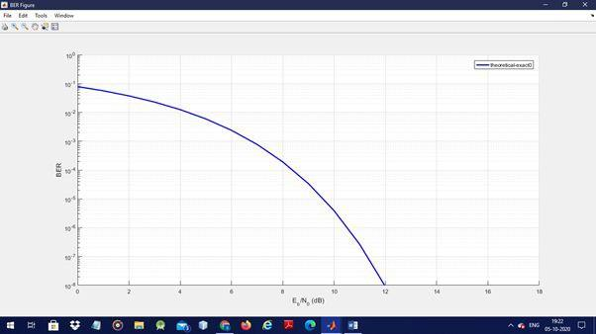

**Plot-2:**

Eb/No:-0.18 dB Channel type: AWGN Modulation type: DPSK Modulation order: 2

## **b) Rayleigh :**

The Rayleigh fading model uses a statistical approach to analyse the propagation, and can be used in a number of environments.

The Rayleigh fading model is ideally suited to situations where there are large numbers of signal paths and reflections. Typical scenarios include cellular telecommunications where there are large numbers of reflections from buildings and the like and also HF ionospheric communications where the uneven nature of the ionosphere means that the overall signal can arrive having taken many different paths.

The Rayleigh fading model is also appropriate for tropospheric radio propagation because, again there are many reflection points and the signal may follow a variety of different paths.

The Rayleigh fading model may be defined as follow:

**Plot-3:**

Eb/No:-0.18 dB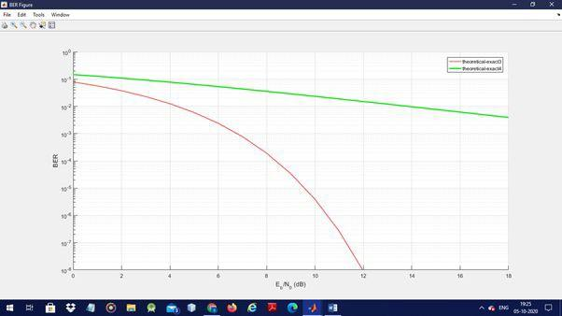

Channel type: Rayleigh

Diversity order: 1

Modulation type: PSK

Modulation order: 2

**Plot-4:**

Eb/No:-0.18 dB

Channel type: Rayleigh

Diversity order: 2

Modulation type: PSK

Modulation order: 2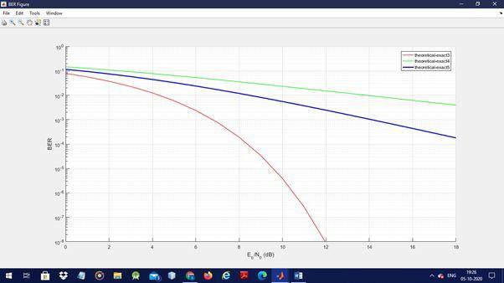

## 

## **c) Rician fading:**

The model behind Rician fading is similar to that for Rayleigh fading, except that in Rician fading a strong dominant component is present. This dominant component can for instance be the line-of-sight wave. Refined Rician models also consider that

* That the dominant wave can be a phasor sum of two or more dominant signals, e.g. the line-of-sight, plus a ground reflection. This combined signal is then mostly treated as a deterministic (fully predictable) process, and that
* The dominant wave can also be subject to shadow attenuation. This is a popular assumption in the modelling of satellite channels.

**Plot-5:**

Eb/No:-0.18 dB

Channel type: Rician

Diversity order: 2

K-factor: 0

Modulation type: PSK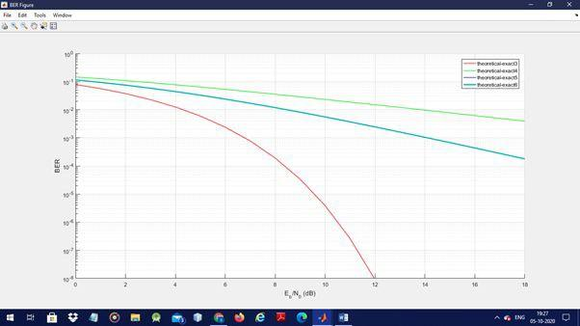

Modulation order: 2

**Plot-6:**

Eb/No:-0.18 dB

Channel type: Rician

Diversity order: 2

K-factor: 1

Modulation type: PSK

Modulation order:1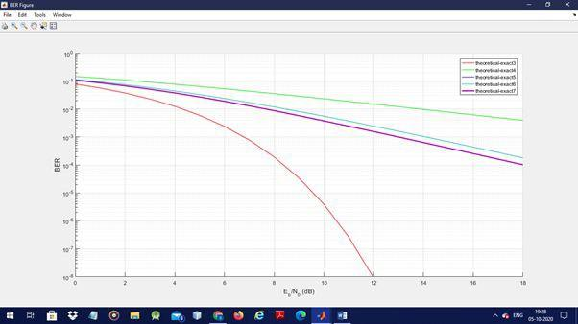

**Result:**

BER Analysis of Digital Communication system using MATLAB has been implemented.

# **EXPERIMENT: 2**

**AIM:**

Simulation of single user and multi-user CDMA System using MATLAB

**THEORY:**

Code Division Multiple Access (CDMA) is a sort of multiplexing that facilitates various signals to occupy a single transmission channel. It optimizes the use of available bandwidth. The technology is commonly used in ultra-high-frequency (UHF) cellular telephone systems, bands ranging between the 800-MHz and 1.9-GHz.

The Code Division Multiple Access system is very different from time and frequency multiplexing. In this system, a user has access to the whole bandwidth for the entire duration. The basic principle is that different CDMA codes are used to distinguish among the different users.Techniques generally used are direct sequence spread spectrum modulation (DS-CDMA), frequency hopping or mixed CDMA detection (JDCDMA). Here, a signal is generated which extends over a wide bandwidth. A code called spreading code is used to perform this action. Using a group of codes, which are orthogonal to each other, it is possible to select a signal with a given code in the presence of many other signals with different orthogonal codes.

CDMA allows up to 61 concurrent users in a 1.2288 MHz channel by processing each voice packet with two PN codes. There are 64 Walsh codes available to differentiate between calls and theoretical limits. Operational limits and quality issues will reduce the maximum number of calls somewhat lower than this value.

In fact, many different "signals" basebands with different spreading codes can be modulated on the same carrier to allow many different users to be supported. Using different orthogonal codes, interference between the signals is minimal. Conversely, when signals are received from several mobile stations, the base station is capable of isolating each as they have different orthogonal spreading codes.

**CDMA Capacity:**

The factors deciding the CDMA capacity are –

* Processing Gain
* Signal to Noise Ratio
* Voice Activity Factor
* Frequency Reuse Efficiency

Capacity in CDMA is soft, CDMA has all users on each frequency and users are separated by code. This means, CDMA operates in the presence of noise and interference.

In addition, neighboring cells use the same frequencies, which means no re-use. So, CDMA capacity calculations should be very simple. No code channel in a cell, multiplied by no cell. But it is not that simple. Although not available code channels are 64, it may not be possible to use a single time, since the CDMA frequency is the same.

Centralized Methods

* The band used in CDMA is 824 MHz to 894 MHz (50 MHz + 20 MHz separation).
* Frequency channels are divided into code channels.
* 1.25 MHz of FDMA channel is divided into 64 code channels.

Processing Gain

CDMA is a spread spectrum technique. Each data bit is spread by a code sequence. This means energy per bit is also increased. This means that we get a gain from this.

### P (gain) = 10log (W/R) W is Spread Rate

**R is Data Rate**

**MATLAB CODE:**

%**Firstly we generate a small random sequence of binary data, that we represent as a %sampled waveform with 64 samples per bit.**

example clear all

data = randi([0,1],1,15);

count = 0; for i = 1:15

for j = 1:64

count = count + 1; data\_exp(count) = data(i);

end end

data\_exp = 2\*data\_exp - 1;

figure(1) plot(data\_exp) axis([1,15\*64,-2,2])

%**Then we generate the spectrum of this signal, to illustrate that it is a fairly narrowband**

%**signal.**

spectrum data\_f = fft(data\_exp); figure(1)

plot(abs(data\_f(1:(15\*32)))) title('data spectrum')

pause

%Then we select one of the Walsh codes, and use it to spread our data. The spreading

%process simply involves multiplying the data line code by the higher rate spreading

%code (the spreading code here is at 64 times the data rate. That is, chip rate = 64 \* data

%rate). The resultant signal is at a much higher data rate – the same as the chip rate.

% generate a spreading code for a user codes = hadamard(64);

user\_code = codes(:,35);

spread = zeros(1,15\*64); count = 0;

for i = 1:15, spread((count+1):(count+64))=data\_exp((count+1):(count+64)).\*(user\_code'); count = count + 64;

end figure(2) plot(spread)

axis([1,15\*64,-2,2])

pause

% The resultant spectrum is much wider in bandwidth than the spectrum of the data

% signal. Note that the code below doesn’t give an accurate rendition of the spectrum of

% the spread signal. Why? spread\_f = fft(spread); figure(12) plot(abs(spread\_f(1:(15\*32)))) title('spread spectrum')

pause

% We can then recover the data from the spread signal by multiplying by the code

% waveform and summing every 64 chips (since 1\*1 = 1 and -1\*-1 = 1, the effect of

% multiplying by the code twice is to recover the original data sequence. Obviously

% synchronisation is an issue – how do we match the code sequence at the transmitter

% and the receiver?

% recover user data count = 0;

for i = 1:15,

data\_desp((count+1):(count+64)) = spread((count+1):(count+64)).\*(user\_code'); count = count + 64;

end

time\_base = 1:(15\*64); count = 0;

for i = 1:15,

data\_rec(i) = sum(data\_desp((count+1):(count+64)))/64; count = count+64;

end

count = 0; for i = 1:15,

for j = 1:64,

count = count + 1; data\_rec\_exp(count) = data\_rec(i);

end end figure(3)

plot(time\_base,data\_rec\_exp,time\_base,data\_exp) axis([1,15\*64,-2,2])

pause

% We can add noise to the CDMA spread signal to such an extent that the signal is

% indistinguishable below the ‘noise floor’.

% now let's add some noise noise = 5\*randn(1,15\*64); noisy\_cdma = spread + noise;

figure(4) plot(noisy\_cdma) axis([1,15\*64,-12,12])

pause

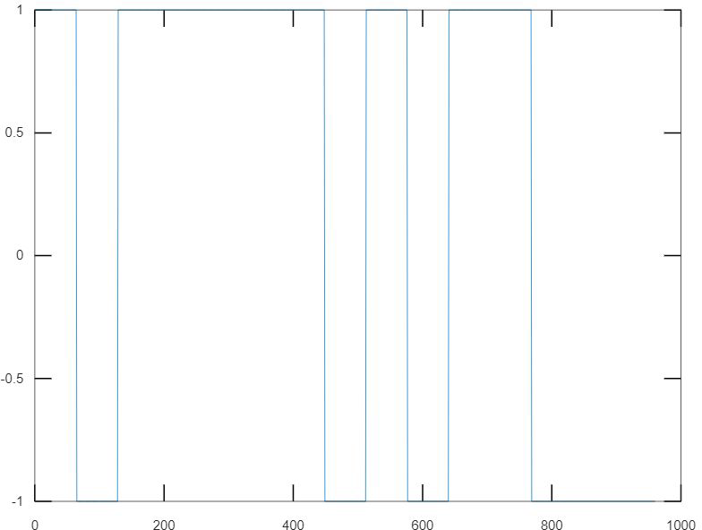

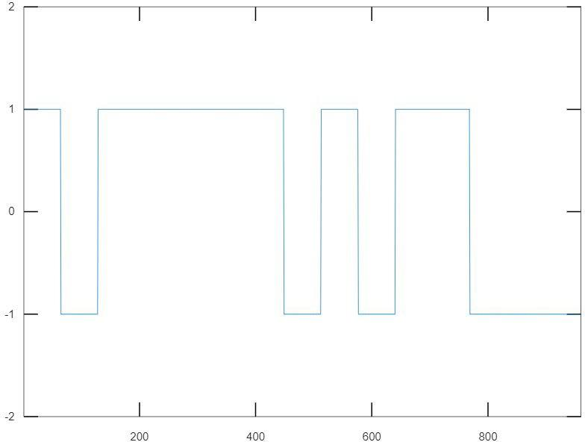

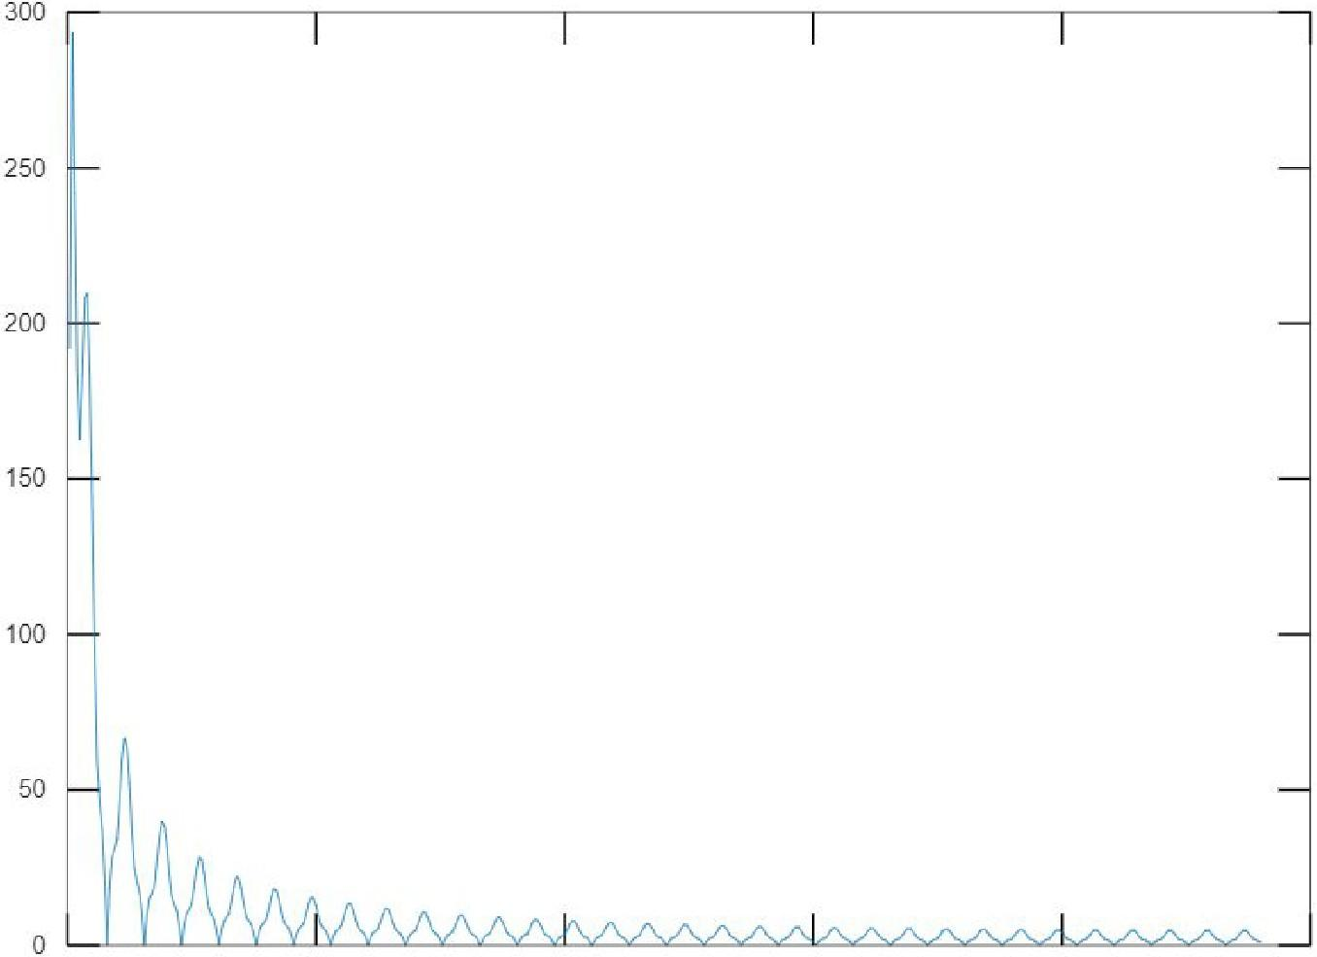

0 100 200 300 400 500

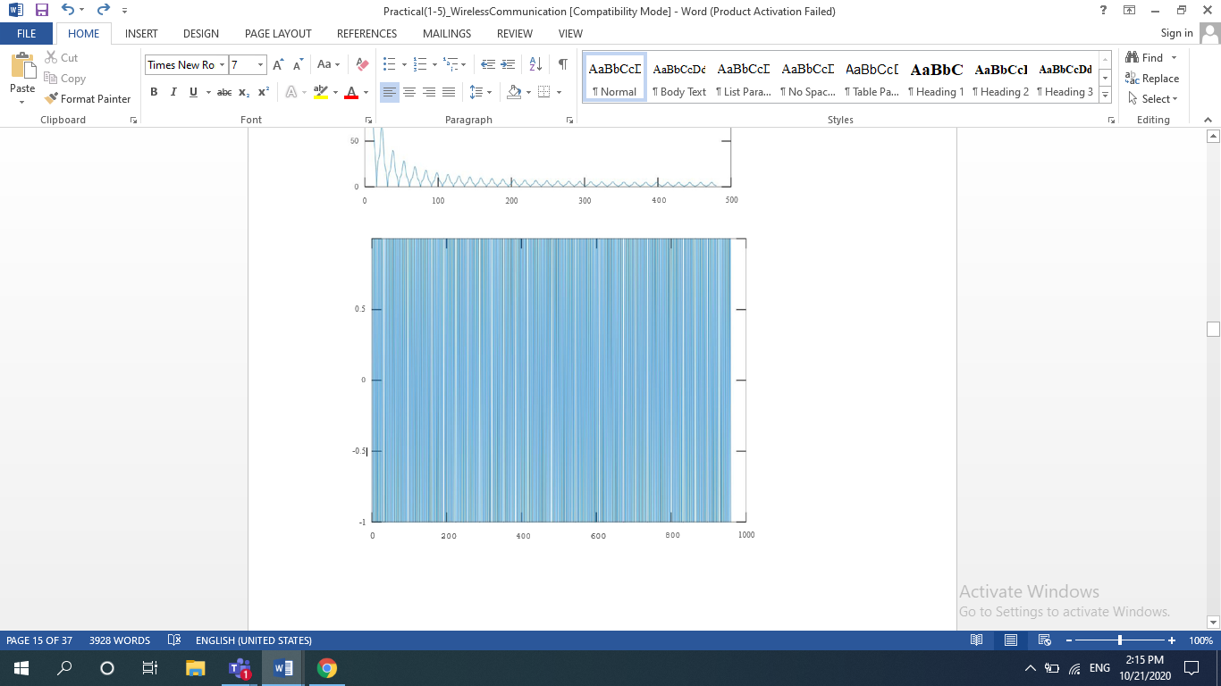

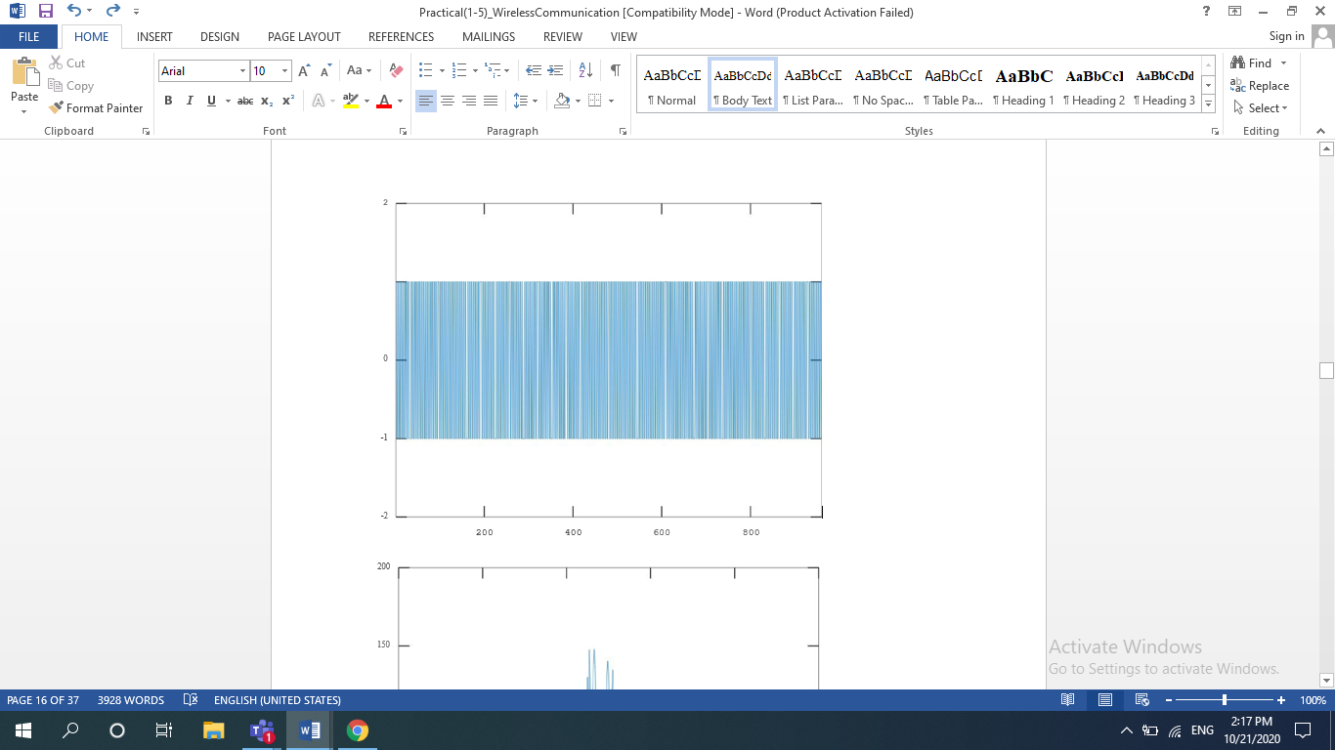

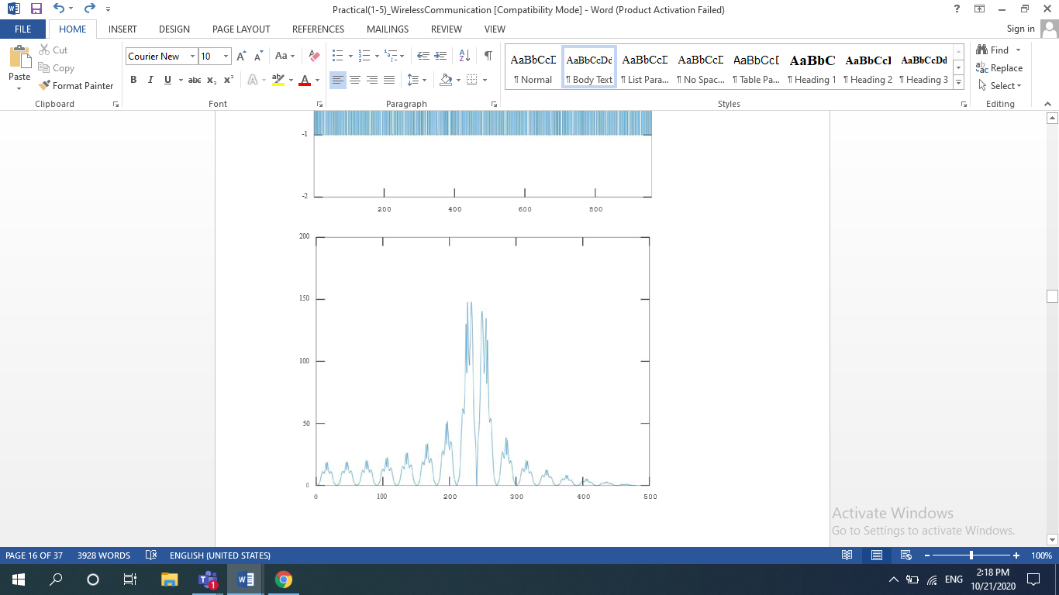

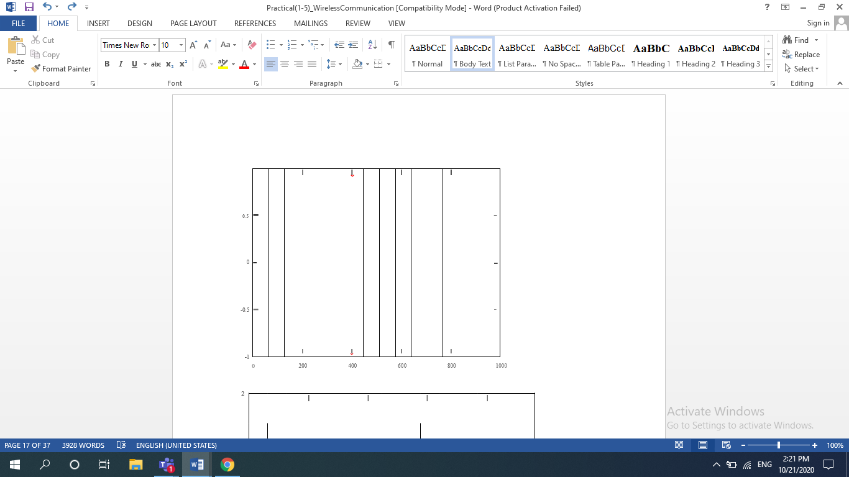

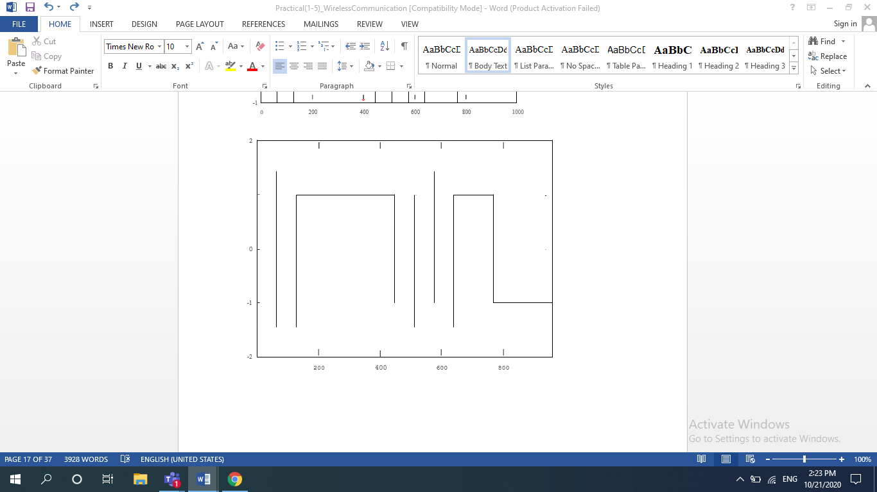

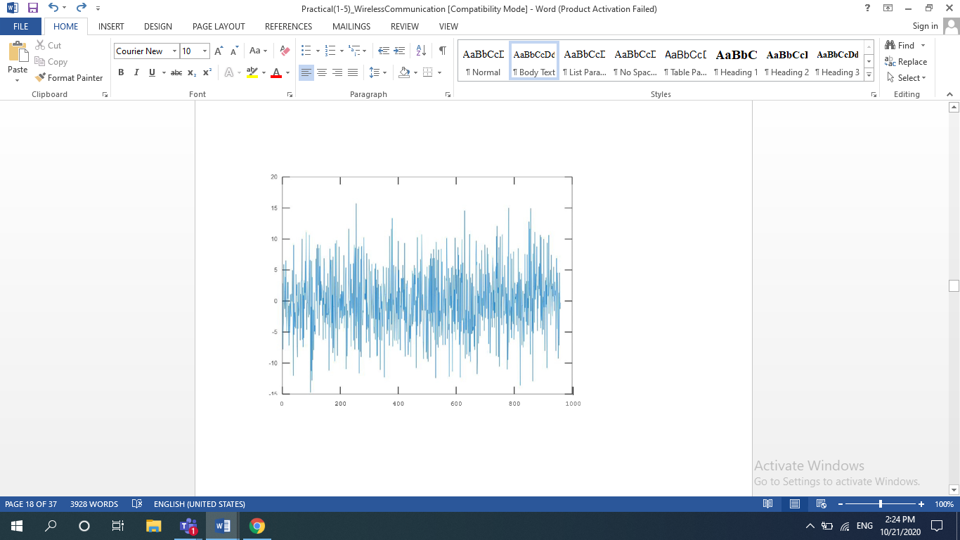

**Result:**

Simulation of single user and multi-user CDMA System using MATLAB has been implemented.

**EXPERIMENT : 3**

**AIM:**

Calculation of Diffraction Loss using Knife Edge Model using MATLAB

**THEORY:**

Diffraction is a phenomenon where electromagnetic waves (such as light waves) bend around corners to reach places which are otherwise not reachable i.e. not in the line of sight. In technical jargon such regions are also called shadowed regions (the term again drawn from the physics of light). This phenomenon can be explained by Huygen’s principle which states that “as a plane wave propagates in a particular direction each new point along the wavefront is a source of secondary waves' . This can be understood by looking at the following figure. However one peculiarity of this principle is that it is unable to explain why the new point source transmits only in the forward direction.

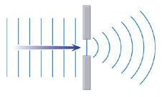

*Fig: Figure showing diffraction*

The electromagnetic field in the shadowed region can be calculated by combining vectorially the contributions of all of these secondary sources, which is a difficult task.

Secondly, the geometry is usually much more complicated than shown in the above figure. For example consider a telecom tower transmitting electromagnetic waves from a rooftop and a pedestrian using a mobile phone at street level. The EM waves usually reach the receiver at street level after more than one diffraction (not to mention multiple reflections). However, an approximation that works well in most cases is called knife edge diffraction, which assumes a single sharp edge (an edge with a thickness much smaller than the wavelength) separates the transmitter and receiver.

###### **Knife Edge Model**

The path loss due to diffraction in the knife edge model is controlled by the Fresnel Diffraction Parameter which measures how deep the receiver is within the shadowed region. A negative value for the parameter shows that the obstruction is below the line of sight and if the value is below -1 there is hardly any loss. A value of 0 (zero) means that the transmitter, receiver and tip of the obstruction are all in line and the Electric Field Strength is reduced by half or the power is reduced to one fourth of the value without the obstruction i.e. a loss of 6dB.  As the value of the Fresnel Diffraction Parameter increases on the positive side the path loss rapidly increases reaching a value of 27 dB for a parameter value of 5. Sometimes the exact calculation is not needed and only an approximate calculation, as proposed by Lee in 1985, is sufficient.

**MATLAB Code:**

% Calculation of the path loss based on the value of

% Fresnel Diffraction Parameter as proposed by Lee

% Lee W C Y Mobile Communications Engineering 1985

% Exact calculation of the path loss (in dB)

% based on Fresnel Diffraction Parameter (v)

% T S Rappaport Wireless Communications P&P

clear all

close all

v=-5:0.01:5;

for n=1:length(v)

if v(n) <= -1

G(n)=0;

elseif v(n) <= 0

G(n)=20\*log10(0.5-0.62\*v(n));

elseif v(n) <= 1

G(n)=20\*log10(0.5\*exp(-0.95\*v(n)));

elseif v(n) <= 2.4

G(n)=20\*log10(0.4-sqrt(0.1184-(0.38-0.1\*v(n))^2));

else

G(n)=20\*log10(0.225/v(n));

end

end

plot(v, G, 'b');hold on;

for n=1:length(v)

v\_vector=v(n):0.01:v(n)+100;

F(n)=((1+1i)/2)\*sum(exp((-1i\*pi\*(v\_vector).^2)/2));

end

F=abs(F)/(abs(F(1)));

plot(v, 20\*log10(F),'r'); hold on;

legend('approximate','exact');

xlabel('Fresnel Diffraction Parameter')

ylabel('Diffraction Loss (dB)')

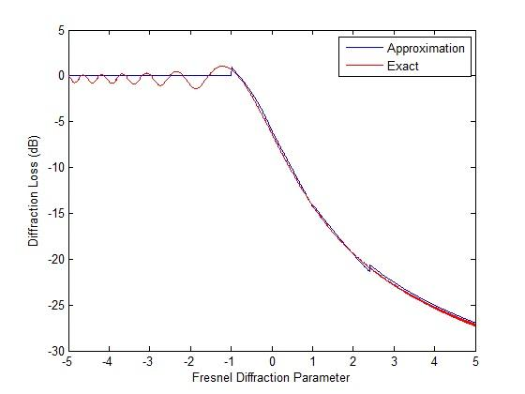

**Result:**

Calculation of Diffraction Loss using Knife Edge Model using MATLAB has been implemented.

**EXPERIMENT: 4**

**AIM:**

Study of various probability distributions through simulations using MATLAB

**THEORY:**

The Rayleigh distribution is a [continuous probability distribution](https://www.statisticshowto.com/continuous-probability-distribution/) named after the English [Lord Rayleigh](http://www-history.mcs.st-and.ac.uk/Biographies/Rayleigh.html). The distribution is widely used:

* In communications theory, to model multiple paths of dense scattered signals reaching a receiver.
* In the physical sciences to model wind speed, wave heights and sound/light radiation.
* In engineering, to measure the lifetime of an object, where the lifetime depends on the object’s age. For example: resistors, transformers, and capacitors in aircraft radar sets.[1](https://www.ncbi.nlm.nih.gov/pmc/articles/PMC4439070/)
* In medical imaging science, to [model noise variance](https://www.academia.edu/8990793/Data_distributions_in_magnetic_resonance_images_A_review) in magnetic resonance imaging.

The Rayleigh distribution is a special case of the [Weibull distribution](https://www.statisticshowto.com/weibull-distribution/) with a scale parameter of 2. When a Rayleigh is set with a [shape parameter](https://www.statisticshowto.com/shape-parameter/) (σ) of 1, it is equal to a [chi square distribution](https://www.statisticshowto.com/probability-and-statistics/chi-square/#chisquaredist)with 2 [degrees of freedom](https://www.statisticshowto.com/probability-and-statistics/hypothesis-testing/degrees-of-freedom/).

The notation *X* Rayleigh(σ) means that the [random variable](https://www.statisticshowto.com/random-variable/) *X* has a Rayleigh distribution with shape parameter σ. The [probability density function](https://www.statisticshowto.com/probability-density-function/) (X > 0) is:  
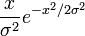

Variance and Mean (Expected Value) of a Rayleigh Distribution

The[expected value](https://www.statisticshowto.com/probability-and-statistics/expected-value/) (the [mean](https://www.statisticshowto.com/mean/)) of a Rayleigh distribution is:  
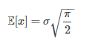  
How this equation is derived involves solving an integral, using calculus:  
The expected value of a [probability distribution](https://www.statisticshowto.com/probability-distribution/) is:  
E(x) = ∫ xf(x)dx.  
Substituting in the Rayleigh probability density function, this becomes:  
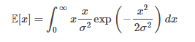

**MATLAB script to generate and**

**1. plot Rayleigh pdf and CDF..**

close all; clear all; clf;

sig=linspace(0.5,1,5);

clr=['-o-','-.-','-+-','--','-x-'];

x=[0:.001:4];

for i=1:length(sig)

fX=x/sig(i)^2.\*exp(-x.^2/(2\*sig(i)^2));

subplot(121),plot(x,fX,clr(i),'LineWidth',3);

grid on; hold on;

end;

xlabel('X'); ylabel('f\_{X}(x)');

title('The Rayleigh pdf');

legend('\sigma = 0.5','\sigma = 0.625',...

'\sigma = 0.75','\sigma = 0.875',...

'\sigma = 1.0');

for i=1:length(sig)

FX=1-exp(-x.^2/(2\*sig(i)^2));

subplot(122),plot(x,FX,clr(i),'LineWidth',2);

grid on; hold on;

end;

xlabel('X'); ylabel('F\_{X}(x)');

title('The Rayleigh CDF');

legend('\sigma = 0.5','\sigma = 0.625',...

'\sigma = 0.75','\sigma = 0.875',...

'\sigma = 1.0');

hold off;

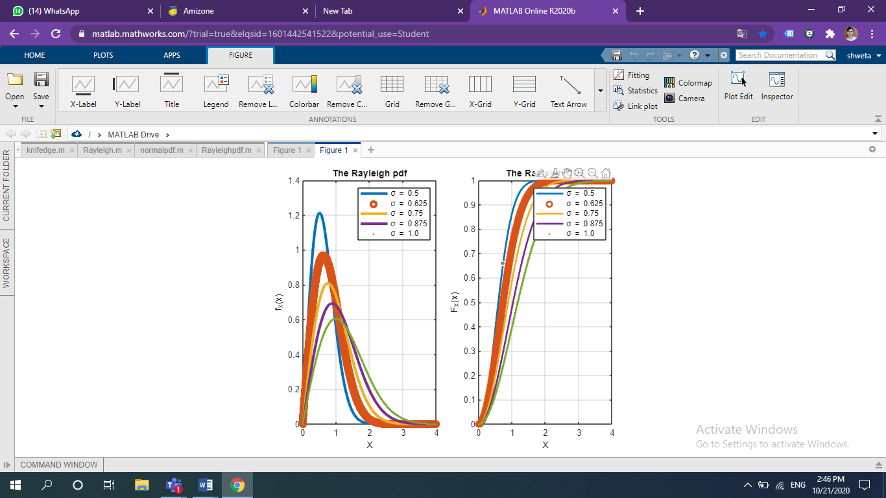

**Nakagami Distribution**

The Nakagami distribution (also called the Nakagami-*m*or Nakagami-*μ* distribution) is a fairly new probability distribution, first appearing in 1960. It is a generalized way to model small scale fading for dense signal scatters and is one of the most common distributions for modeling right-skewed, positive data sets. Real world applications include modeling wireless signal and radio wave propagation, characterizing breast tumors using ultrasound imaging and in [meteorology](https://ntrs.nasa.gov/search.jsp?R=19640015614). The probability density function formula is:  
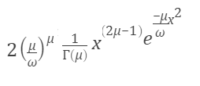

**Where**

* μ is the [shape parameter](https://www.statisticshowto.com/shape-parameter/).
* ω is the [scale parameter](https://www.statisticshowto.com/scale-parameter/) (ω > 0 for all x > 0). This parameter controls the spread of the distribution.

**MATLAB script to generate and**

**2. plot Nakagami-m pdf and CDF.**

close all; clear all; clf;

m=[0.5,1,1,1,2,2,5];

o=[2,1,2,3,1,2,1];

x=[0:.001:3];

clr=['-o-','-.-','-+-','-x-','..','+-'];

for i=1:length(m)

fX= 2\*m(i)^m(i)/(gamma(m(i))\*o(i)^m(i))...

\*x.^(2\*m(i)-1).\*exp(-(m(i)/o(i))\*x.^2);

subplot(121),plot(x,fX,clr(i),'LineWidth',3);

grid on;hold on;

end;

xlabel('X'); ylabel('f\_{X}(x)');

title('The Nakagami-m pdf');

legend('\mu = 0.5, \omega=2', '\mu = 1, \omega=1',...

'\mu = 1, \omega=2','\mu = 1, \omega=3',...

'\mu = 2, \omega=1','\mu = 2, \omega=2',...

'\mu = 5, \omega=1');

for i=1:length(m)

FX= gammainc((m(i)/o(i))\*x.^2,m(i));

subplot(122),plot(x,FX,clr(i),'LineWidth',3);

grid on; hold on;

end;

xlabel('X'); ylabel('F\_{X}(x)');

title('The Nakagami-m CDF');

legend('\mu = 0.5, \omega=2', '\mu = 1, \omega=1',...

'\mu = 1, \omega=2','\mu = 1, \omega=3',...

'\mu = 2, \omega=1','\mu = 2, \omega=2',...

'\mu = 5, \omega=1');

hold off;

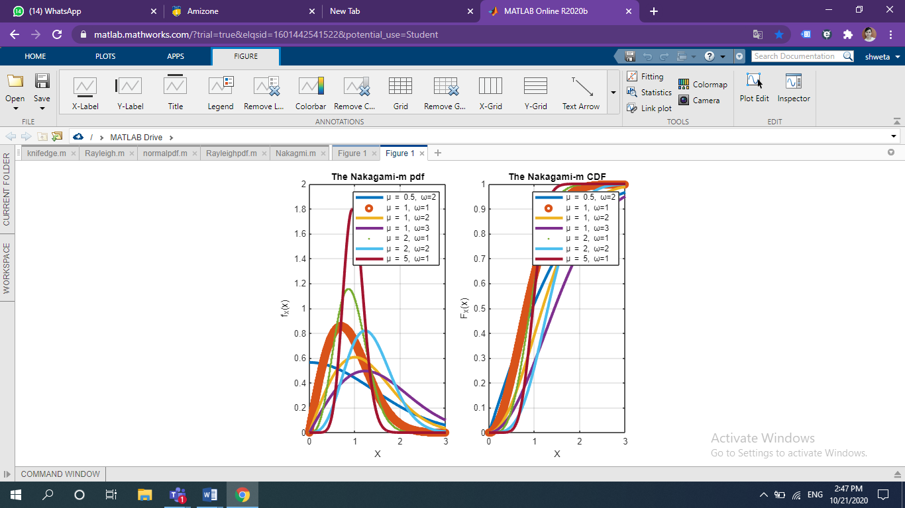

## **Log-normal Distribution**

A lognormal (log-normal or Galton) distribution is a probability distribution with a normally distributed logarithm. A [random variable](https://www.statisticshowto.com/random-variable/) is lognormally distributed if its logarithm is normally distributed.

[Skewed distributions](https://www.statisticshowto.com/probability-and-statistics/skewed-distribution/) with low mean values, large [variance](https://www.statisticshowto.com/probability-and-statistics/variance/), and all-positive values often fit this type of distribution. Values must be positive as log(x) exists only for positive values of x.

The probability density function is defined by the [mean](https://www.statisticshowto.com/mean/)μ and [standard deviation](https://www.statisticshowto.com/probability-and-statistics/standard-deviation/), σ:  
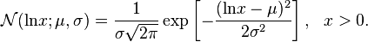

The shape of the lognormal distribution is defined by three parameters:

* σ, the [shape parameter](https://www.statisticshowto.com/shape-parameter/). Also the standard deviation for the lognormal, this affects the general shape of the distribution. Usually, these parameters are known from historical data. Sometimes, you might be able to estimate it with current data. The shape parameter doesn’t change the location or height of the graph; it just affects the overall shape.
* m, the [scale parameter](https://www.statisticshowto.com/scale-parameter/) (this is also the median). This parameter shrinks or stretches the graph.
* Θ (or μ), the [location parameter](https://www.statisticshowto.com/location-parameter/), which tells you where on the x-axis the graph is located.

% MATLAB script to generate

% 3. plot Log-normal pdf and CDF.

close all; clear all; clf;

mu=0;

sig=[0.125, 0.25, 0.5, 1, 2];

x=[0:.001:3];

clr=['-o-','-.-','-+-','--','-\*-'];

for i=1:length(sig)

fX= 1./(x\*sig(i)\*sqrt(2\*pi)).\*exp(-(log(x)...

-mu^2).^2/(2\*sig(i)^2));

subplot(121),plot(x,fX,clr(i),'LineWidth',2);

grid on;hold on;

end;

xlabel('X'); ylabel('f\_{X}(x)');

title('The Log-normal pdf');

legend('\sigma = 0.125', '\sigma = 0.25',...

'\sigma = 0.5', '\sigma = 1','\sigma = 2');

for i=1:length(sig)

FX=0.5+0.5\*erf( (log(x)-mu)/(sig(i)\*sqrt(2)));

subplot(122),plot(x,FX,clr(i),'LineWidth',2);

grid on;hold on;

end;

xlabel('X'); ylabel('F\_{X}(x)');

title('The Log-normal CDF');

legend('\sigma = 0.125', '\sigma = 0.25',...

'\sigma = 0.5', '\sigma = 1','\sigma = 2');

hold off;

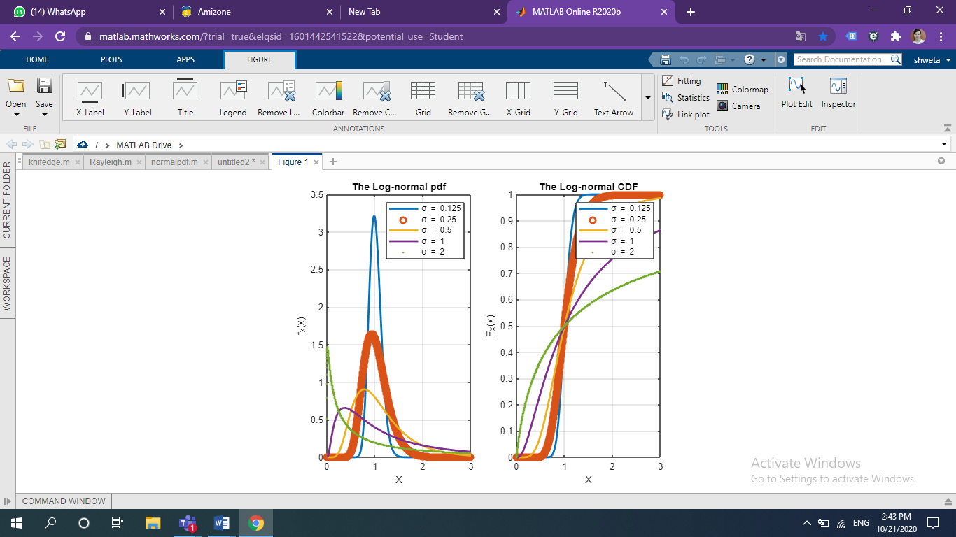

**Gamma Distribution**

The gamma distribution is a two-parameter family of curves. The gamma distribution models sums of exponentially distributed random variables and generalizes both the chi-square and exponential distributions.

Statistics and Machine Learning Toolbox offers several ways to work with the gamma distribution.

* Create a probability distribution object [GammaDistribution](https://www.mathworks.com/help/stats/prob.gammadistribution.html) by fitting a probability distribution to sample data ([fitdist](https://www.mathworks.com/help/stats/fitdist.html)) or by specifying parameter values ([makedist](https://www.mathworks.com/help/stats/makedist.html)). Then, use object functions to

The pdf of the gamma distribution is

*y*=*f*(*x*↓*a*,*b*)=1*ba*Γ(*a*)*xa*−1*e*−*xb*,

where Γ( · ) is the Gamma function.

The cumulative distribution function (cdf) of the gamma distribution is

*p*=*F*(*x*↓*a*,*b*)=1*ba*Γ(*a*)*x*Ζ0*ta*−1*e*−*tbdt*.

The result *p* is the probability that a single observation from the gamma distribution with parameters *a* and *b* falls in the interval [0 *x*].

**MATLAB script to generate and**

**4. plot Gamma pdf and CDF.**

close all; clear all; clf;

b=linspace(0.2,2,5);

c=linspace(2,10,5);

x=[0:.001:25];

clr=['-o-','-.-','-+-','--','-x-'];

for i=1:length(b)

fX= (x/b(i)).^(c(i)-1).\*exp(-x/b(i))/...

(b(i)\*gamma(c(i)));

subplot(121),plot(x,fX,clr(i),'LineWidth',2);

grid on;hold on;

end;

xlabel('X'); ylabel('f\_{X}(x)');

title('The Gamma pdf');

legend('b = 0.2, c = 2', 'b = 0.65, c = 4',...

'b = 1.1, c = 6', 'b = 1.55, c = 8', ...

'b = 2, c = 10');

for i=1:length(b)

FX= gammainc(x/b(i),c(i));

subplot(122),plot(x,FX,clr(i),'LineWidth',2);

grid on;hold on;

end;

xlabel('X'); ylabel('F\_{X}(x)');

title('The Gamma CDF');

legend('b = 0.2, c = 2', 'b = 0.65, c = 4',...

'b = 1.1, c = 6', 'b = 1.55, c = 8', ...

'b = 2, c = 10');

hold off;

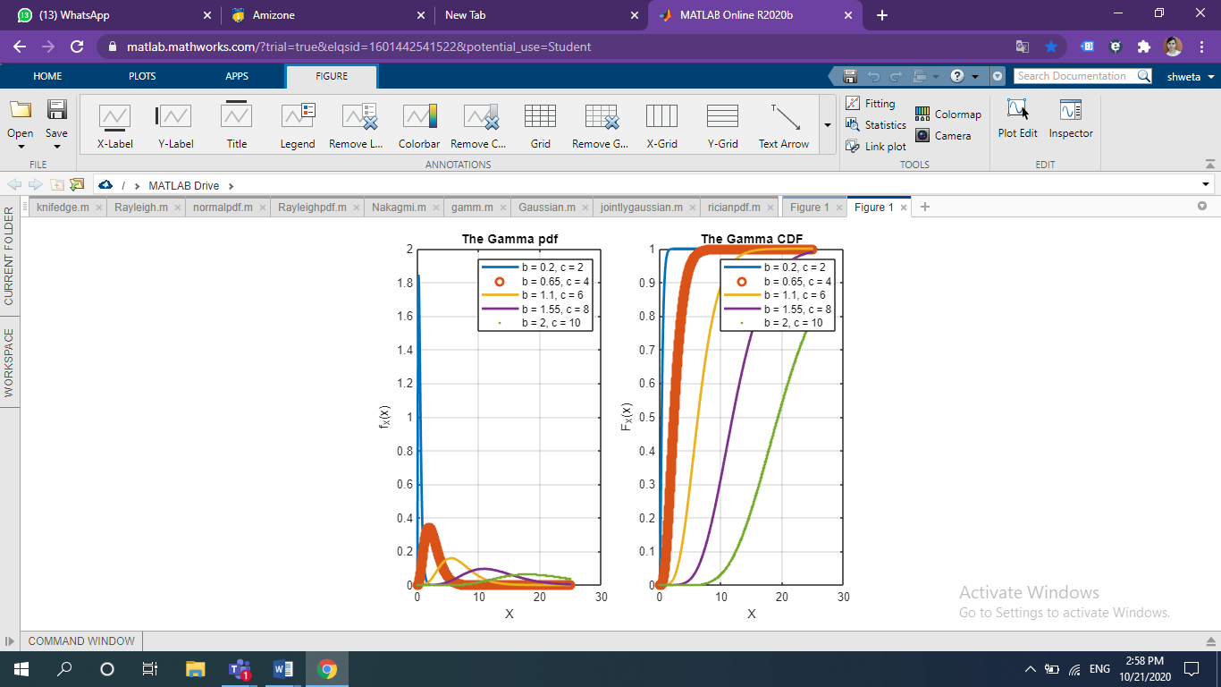

**Gaussian distribution**

The Gaussian distribution is also commonly called the "normal distribution" and is often described as a "bell-shaped curve

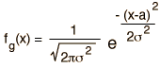

**MATLAB script to generate and**

**5. plot Gaussian pdf and CDF**

close all; clear all; clf;

sig=sqrt(linspace(0.16,1,5));

m=linspace(-4,4,5);

clr=['o-','-.-','+-','-o','-\*'];

x=[-10:.05:10];

for i=1:length(sig)

fX=1/(sqrt(2\*pi\*sig(i)^2))\*exp(-(x-m(i)).^2/(2\*sig(i)^2));

subplot(121),plot(x,fX,clr(i),'LineWidth',2);

grid on;hold on;

end;

xlabel('X'); ylabel('f\_{X}(x)');

title('The Gaussian pdf');

legend('\mu = -4, \sigma = 0.4','\mu = -2, \sigma = 0.61',...

'\mu = 0, \sigma = 0.76','\mu = 2, \sigma = 0.89',...

'\mu = 4, \sigma = 1.0');

for i=1:length(sig)

% FX=0.5\*erfc(-x/sqrt(2));

FX=normcdf(x,m(i),sig(i));

% The normcdf(.) is available only in

% Statistics Toolbox of MATLAB....

subplot(122),plot(x,FX,clr(i), 'LineWidth',2);

grid on; hold on;

end;

xlabel('X'); ylabel('F\_{X}(x)');

title('The Gaussian CDF');

legend('\mu = -4, \sigma = 0.4','\mu = -2, \sigma = 0.61',...

'\mu = 0, \sigma = 0.76','\mu = 2, \sigma = 0.89',...

'\mu = 4, \sigma = 1.0');

hold off;

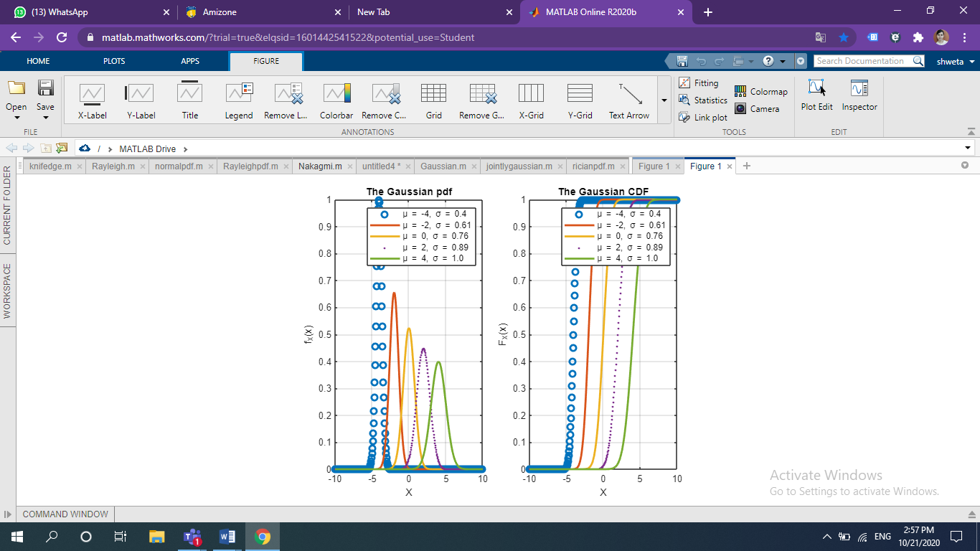

**Logistic distribution**

The logistic distribution is used for modeling growth, and also for [logistic regression](https://www.statisticshowto.com/logistic-regression/). It is [symmetrical](https://www.statisticshowto.com/symmetric-distribution-2/), [unimodal](https://www.statisticshowto.com/unimodal-distribution-2/)(it has one peak) and is similar in shape to the [normal distribution](https://www.statisticshowto.com/probability-and-statistics/normal-distributions/). In fact, the logistic and normal distributions are so close in shape (although the logistic tends to have slightly fatter tails) that for most applications it’s impossible to tell one from the other.

The logistic distribution is mainly used because the curve has a relatively simple [cumulative distribution](https://www.statisticshowto.com/cumulative-distribution-function/) formula to work with. The formula approximates the normal distribution extremely well.

Finding cumulative probabilities for the normal distribution usually involves looking up values in the [z-table](https://www.statisticshowto.com/tables/z-table/), rounding up or down to the nearest [z-score](https://www.statisticshowto.com/probability-and-statistics/z-score/). Exact values are usually found with statistical software, because the cumulative distribution function is so difficult to work with, involving integration:  
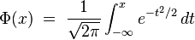

**MATLAB script to generate and**

**6. plot Logistic pdf and CDF.**

close all; clear all; clf;

a=1;

b=[1,2,4,8,16];

x=[0:.001:2];

clr=['bk','r','b','g','m'];

for i=1:length(b)

fX= b(i)\*x.^(b(i)-1)./(1+x.^b(i)).^2;

subplot(121),plot(x,fX,clr(i),'LineWidth',2);

hold on;

end;

xlabel('X'); ylabel('f\_{X}(x)');

title('The Log-logistic pdf');

legend('\beta = 1','\beta = 2','\beta = 4',...

'\beta = 8','\beta =16');

for i=1:length(b)

FX= x.^b(i)./(1+x.^(b(i)));

subplot(122),plot(x,FX,clr(i),'LineWidth',2);

hold on;

end;

xlabel('X'); ylabel('F\_{X}(x)');

title('The Logistic CDF');

legend('\beta = 1','\beta = 2','\beta = 4',...

'\beta = 8','\beta =16');

hold off;

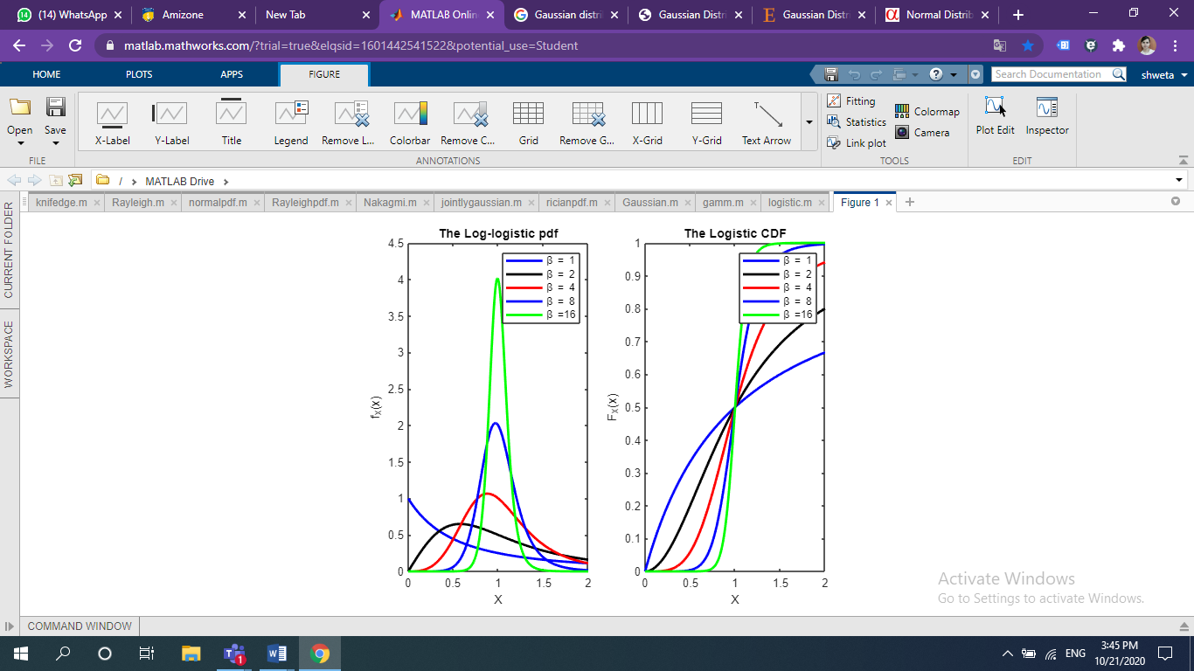

**Rice/Rician Distribution**

A Rice or Rician distribution (also known as a Nakagami-n distribution) is one way to model the paths scattered signals take to a receiver. Specifically, this distribution models line-of-sight scatter — transmissions between two stations in view of each other that have an unobstructed path between them. [Line-of-sight scatter](https://www.techopedia.com/definition/5069/line-of-sight-los) includes FM radio waves, microwaves, MRI images in the presence of noise, and satellite transmissions. The distribution also models **Rician fading**, which is a way to show how signal cancellations affect radio propagation.

The probability density function formula is:  
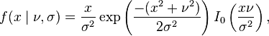

**MATLAB script to generate and**

**8. plot Rician pdf**.

close all; clear all; clf;

sig=0.9;

a=linspace(0.5,2,5);

x=[0:.001:4];

clr=['-o-','-.-','-+-','--','-x-'];

for i=1:length(a)

fX=x/sig^2.\*exp(-(x.^2+a(i)^2)/...

(2\*sig^2)).\*besselj(1,a(i)\*x/sig^2);

plot(x,fX,clr(i),'LineWidth',3);

grid on; hold on;

end;

xlabel('X'); ylabel('f\_{X}(x)');

title('The Rician pdf');

legend('a = 0.5', 'a = 0.875',...

'a = 1.25', 'a = 1.625', 'a = 2');

hold off;

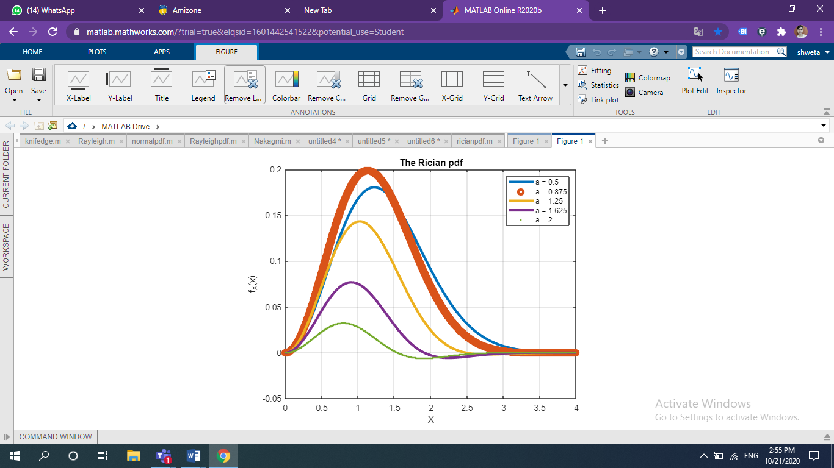

**Weibull Distribution**

The Weibull distribution is a [continuous probability distribution](https://www.statisticshowto.com/continuous-probability-distribution/) named after Swedish mathematician Waloddi Weibull. He originally proposed the distribution as a model for material breaking strength, but recognized the potential of the distribution in his 1951 paper *A Statistical Distribution Function of Wide Applicability*. Today, it’s commonly used to [assess product reliability](http://www.itl.nist.gov/div898/handbook/apr/apr.htm), [analyze life data](http://wildeanalysis.co.uk/reliability/applications/life-data-analysis) and model failure times**.**The Weibull can also fit a wide range of data from many other fields, including: biology, economics, engineering sciences, and hydrology (Rinne, 2008).

Although it’s extremely useful in most cases, the Weibull isn’t an appropriate model for every situation. For example, chemical reactions and corrosion failures are usually modeled with the [lognormal distribution](https://www.statisticshowto.com/lognormal-distribution/).

**Weibull Distribution PDFs**

Two versions of the Weibull [probability density function (pdf)](https://www.statisticshowto.com/probability-density-function/) are in common use: the *two parameter pdf* and the *three parameter pdf*. **Different authors use different notation, which makes the notation a little confusing if you’re looking at different texts.** For example, The Engineering Statistics Handbook uses gamma(γ) to represent the [shape parameter](https://www.statisticshowto.com/shape-parameter/), while other authors (e.g. Fritz Scholz, writing for Boeing) use beta (β). I’ve included the different notations I have found in the pdf information below. If you find more, please don’t hesitate to let me know by leaving a comment on our [Facebook page](https://www.facebook.com/statisticshowto/).

For clarity, I’m staying with the same notation for all formulas: γ for the shape parameter, x as the variable, and μ for the location parameter.

**MATLAB script to generate and**

**9. plot Weibull pdf and CDF.**

close all; clear all; clf;

lam=[0.5,1,1.5,3];

k=[2,2,3,4];

x=[0:.001:5];

clr=['-o-','-.-','-+-','-x-'];

for i=1:length(k)

fX=k(i)/lam(i)\*(x/lam(i)).^(k(i)-1).\*exp(-(x/lam(i))).^k(i);

subplot(121),plot(x,fX,clr(i),'LineWidth',3);

grid on;hold on;

end;

xlabel('X'); ylabel('f\_{X}(x)');

title('The Weibull pdf');

legend('\lambda = 0.5, k=2', '\lambda = 1.0, k=2', ...

'\lambda = 1.5, k=3', '\lambda = 3.0, k=4');

for i=1:length(k)

FX=1-exp(-(x/lam(i)).^k(i));

subplot(122),plot(x,FX,clr(i),'LineWidth',3);

grid on;hold on;

end;

xlabel('X'); ylabel('F\_{X}(x)');

title('The Weibull CDF');

legend('\lambda = 0.5, k=2', '\lambda = 1.0, k=2', ...

'\lambda = 1.5, k=3', '\lambda = 3.0, k=4');

hold off;

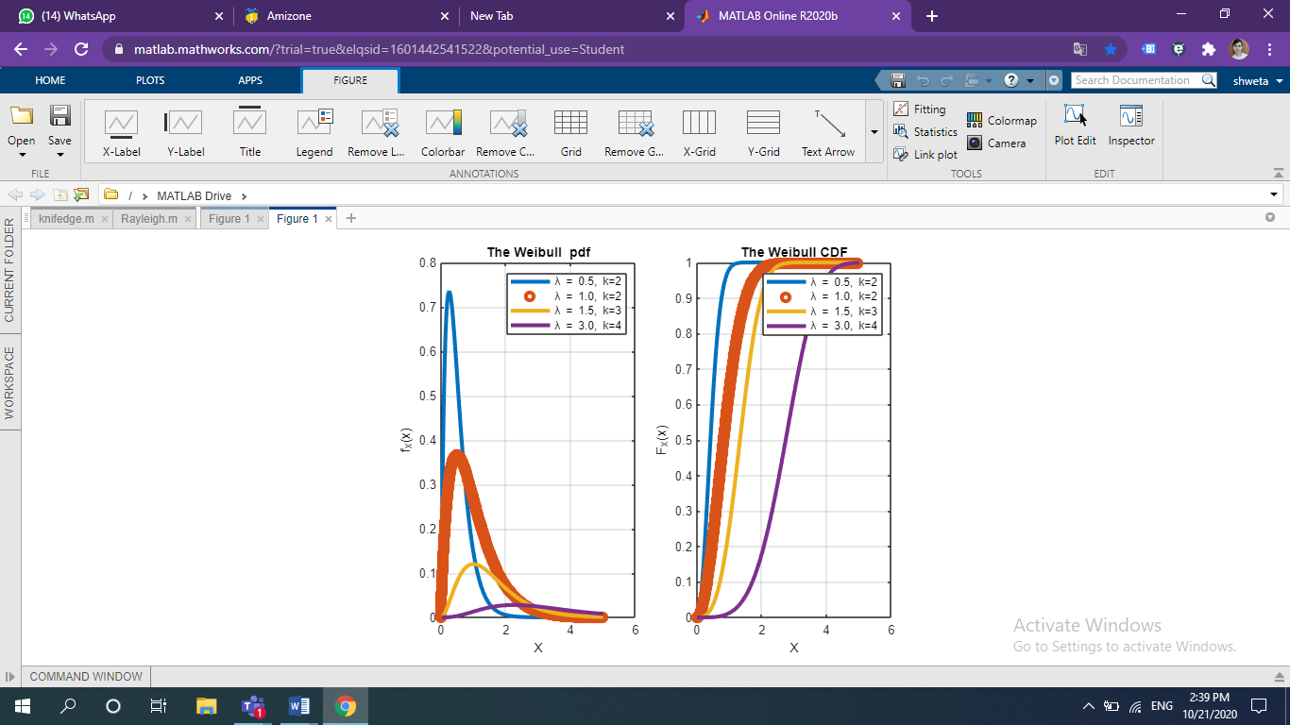

**Result:**

Study of various probability distributions through simulations using MATLAB has been implemented.

# **EXPERIMENT: 5**

**AIM:**

Study of Rayleigh Channel Model using MATLAB

### **THEORY:**

### **Rayleigh Channel**

The Rayleigh probability distribution function defines the LTE channel. This type of channel has an impulse response given by a delta which weighted has a power distribution function of Rayleigh:

The characteristic power distribution function envelope of a received signal with fading is:

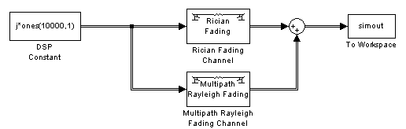

*Fig: Block diagram of Rayleigh Fading Distribution*

While the mobile station is in motion, the received signal fades away and the weight of the delta function also changes according to the Rayleigh distribution. If the mobile station suffers a deep fade, the weight of the delta is small and when the received signal is improved, the weight of the delta is large.

Recall a Gaussian channel can be represented as an impulse response with a delta of constant weight; an ideal channel plus a source of AWGN (Additive White Gaussian Noise). The noise of this channel is AWGN.

A multipath channel can be expressed as a linear filter and time varying, the same which can be deduced as the sum of different paths with their own delay and complex amplitude

This model is used to characterize the rapid variations of the received signal strength due to changes in phases when a mobile terminal moves over small distances close to a few wavelengths or over short time durations on the order of seconds. Since the mean power remains constant over these small distances, small scale fading can be considered as superimposed on large scale fading for large scale models.

**MATLAB Code:**

%rayleighdemo.m

DATA=round(rand(1,10000));

TX=[];

a=1;

%Let the bandwidth of the complex baseband signal be W/2

W=2;

N0=0.01;

N0W=(N0/2)\*W;

for i=1:1:length(DATA)

if(DATA(i)==0)

TX=[TX a 0];

else

TX=[TX 0 a];

end

end

%Gaussian noise with variance 0.01

g=sqrt(N0W)\*randn(1,20000)+j\*sqrt(N0W)\*randn(1,20000);

%Flat-fading rayleigh channel with impulse response r

r=sqrt(0.1)\*randn(1,20000)+j\*sqrt(0.1)\*randn(1,20000);

RX=r.\*TX+g;

figure

subplot(2,2,1)

stem(TX(1:1:200))

title('Typical transmitted samples')

subplot(2,2,2)

[a,b]=hist(sqrt(abs(r)),100)

plot(b,a)

title('histogram of the rayleigh distributed noise')

subplot(2,2,3)

plot(real(RX(1:1:200)))

title('Real part of the received samples')

subplot(2,2,4)

plot(imag(RX(1:1:200)))

title('Imaginary part of the received samples')

%detection

DETDATA=[];

for i=1:2:200

temp=[RX(i) RX(i+1)];

O=abs(temp(1))-abs(temp(2));

if(O>0)

DETDATA=[DETDATA 0];

else

DETDATA=[DETDATA 1];

end

end

figure

subplot(2,1,1)

stem(DATA(1:1:100))

title('Transmitted data')

subplot(2,1,2)

stem(DETDATA,'r')

title('Corresponding detected data')

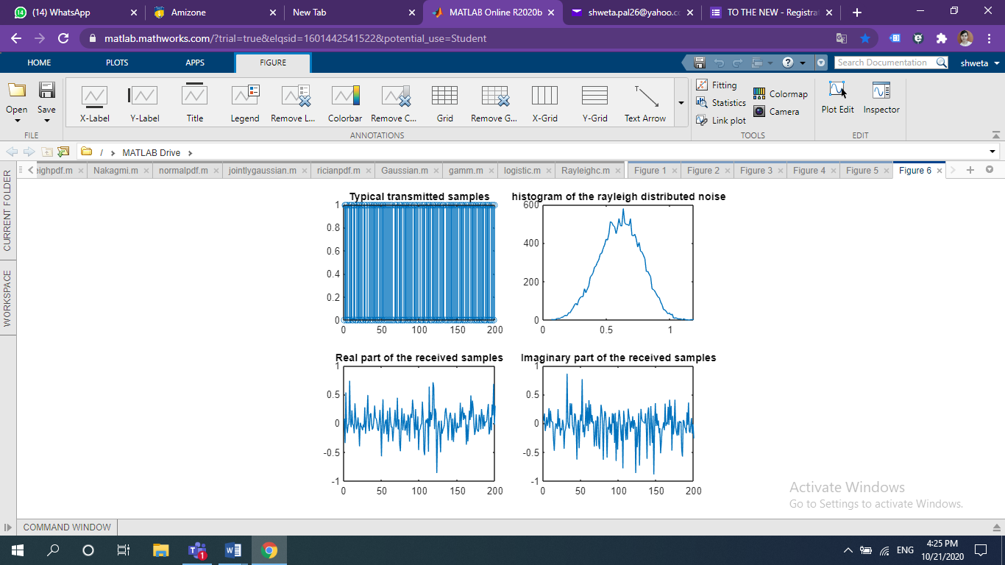

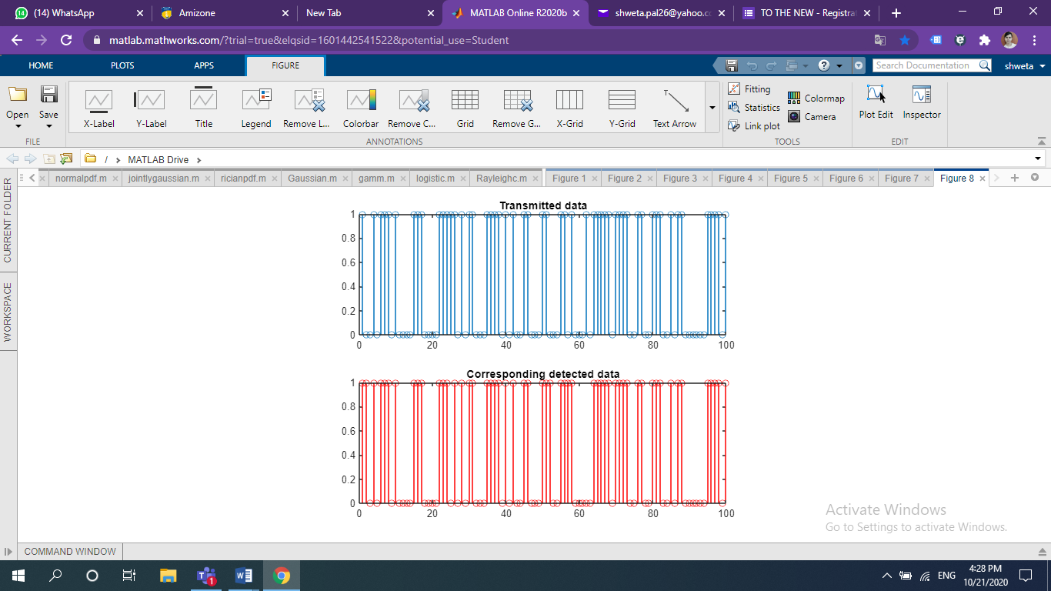

**Result:**

Study of Rayleigh Channel Model using MATLAB has been implemented

**Experiment 6**

**Aim:**

Study of Rician channel model using MATLAB

**Theory:**

The model behind Rician fading is similar to that for Rayleigh fading, except that in Rician fading a strong dominant component is present. This dominant component can for instance be the line-of-sight wave. Refined Rician models also consider that

* the dominant wave can be a phasor sum of two or more dominant signals, e.g. the line-of-sight, plus a ground reflection. This combined signal is then mostly treated as a deterministic (fully predictable) process, and that
* The dominant wave can also be subject to shadow attenuation. This is a popular assumption in the modelling of satellite channels.

Besides the dominant component, the mobile antenna receives a large number of reflected and scattered waves.

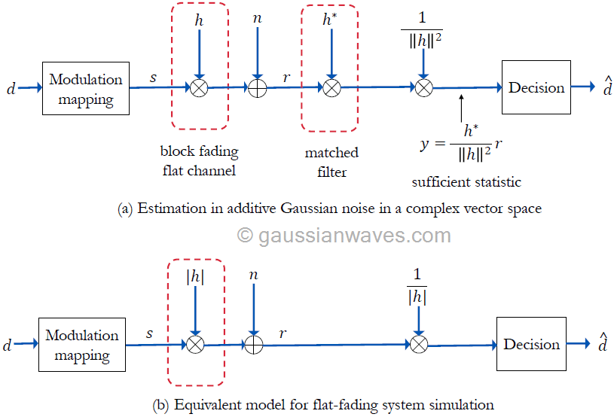

**PDF of signal amplitude**

The derivation of the probability density function of amplitude is more involved than for Rayleigh fading, and a Bessel function occurs in the mathematical expression.

Probability density function of Rician distributions: K=- ∞dB (Rayleigh) and K=6dB. For K>>1, the Ricean pdf is approximately Gaussian about the mean.

**Cumulative distribution** for three small-scale fading measurements and their fit to Rayleigh, Rician, and lognormal distributions.

**MATLAB Code:**

DATA=round(rand(1,10000));

TX=[];

a=1;

%Let the bandwidth of the complex base band signal be W/2

W=2;

N0=0.01;

N0W=(N0/2)\*W;

for i=1:1:length(DATA)

if(DATA(i)==0)

TX=[TX a 0];

else

TX=[TX 0 a];

end

end

m=1;

%Gaussian noise with variance 0.01

g=sqrt(N0W)\*randn(1,20000)+j\*sqrt(N0W)\*randn(1,20000);

%Flat-fading rician channel with impulse response r

r=sqrt(0.1)\*randn(1,20000)+1+j\*sqrt(0.1)\*randn(1,20000);

RX=r.\*TX+g;

figure

subplot(2,2,1)

stem(TX(1:1:200))

title('Typical transmitted samples')

subplot(2,2,2)

[a,b]=hist(sqrt(abs(r)),100);

plot(b,a)

title('histogram of the rician distributed noise')

subplot(2,2,3)

plot(real(RX(1:1:200)))

title('Real part of the received samples')

subplot(2,2,4)

plot(imag(RX(1:1:200)))

title('Imaginary part of the received samples')

%detection

DETDATA=[];

for i=1:2:200

temp=[RX(i) RX(i+1)];

O=abs(temp(1))-abs(temp(2));

if(O>0)

DETDATA=[DETDATA 0];

else

DETDATA=[DETDATA 1];

end

end

figure

subplot(2,1,1)

stem(DATA(1:1:100))

title('Transmitted data')

subplot(2,1,2)

stem(DETDATA,'r')

title('Corresponding detected data')

**Output:**

**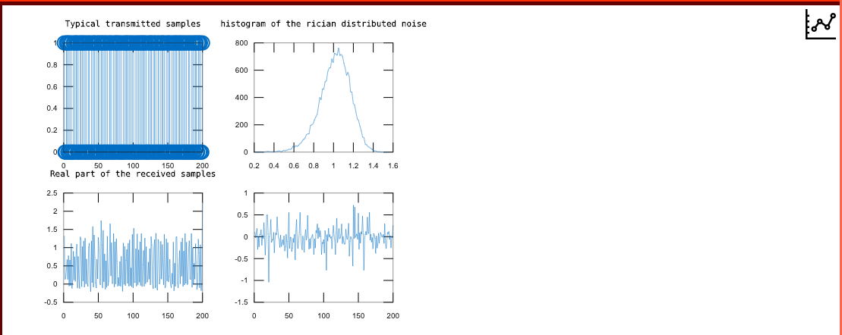**

**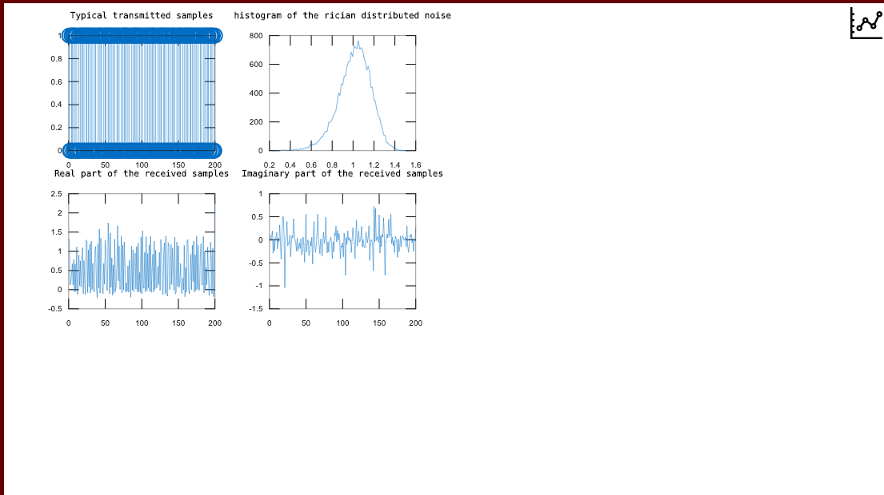**

**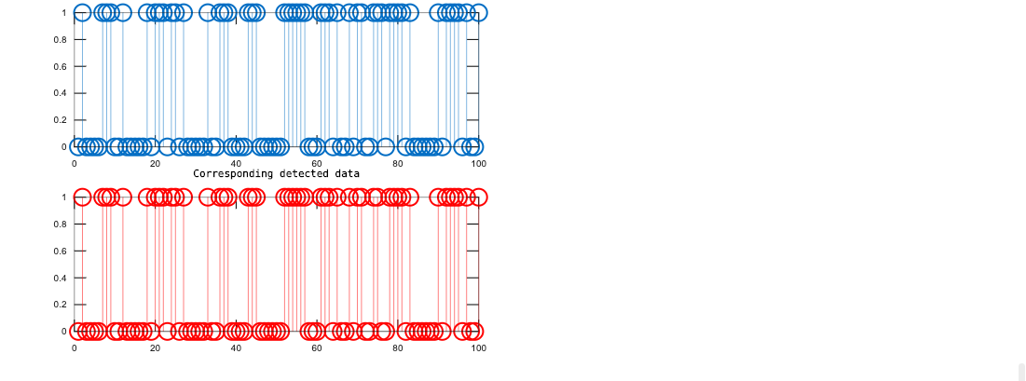**

**EXPERIMENT 7**

**Aim:**

Study of CDMA Transmitter using CDMA Trainer Kit

**Apparatus:**

CDMA Trainer Kit, CDMA sim card

**Theory:**

Code Division Multiple Access (CDMA) is a promising technique for radio access in cellular mobile and personal communication systems. CDMA in cellular systems offers attractive features such as the potential for high spectrum efficiency, soft capacity, soft handover and macro-diversity. This has been claimed and demonstrated in various system design studies, analyses and trials. CDMA techniques are based on spread spectrum communications, which were originally developed for military applications. A simple definition of a spread spectrum signal is that its transmission bandwidth is much wider than the bandwidth of the original signal. In a CDMA communications system, a unique binary spreading sequence (a code) is assigned for each call to every user.

In a CDMA transmitter, the information signal is modulated by spreading code, and in the receiver it is correlated with a replica of the same code. Thus, low cross-correlation between the desired and interfering users is important to suppress the multiple access interference. Good autocorrelation properties are required for reliable synchronization and reliable separation of the multipath components. Having good autocorrelation properties is also an indication of good randomness of a sequence which allows us to connect another important sequence’s property: cross-correlation.

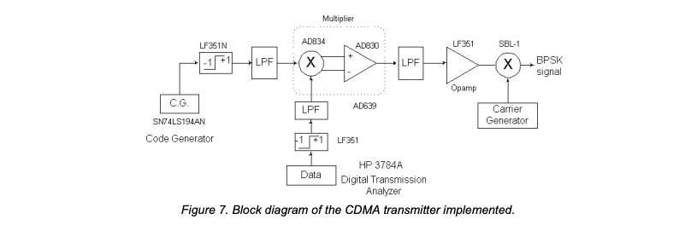

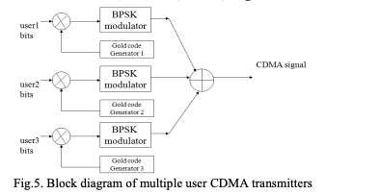

**CDMA BLOCKS:**

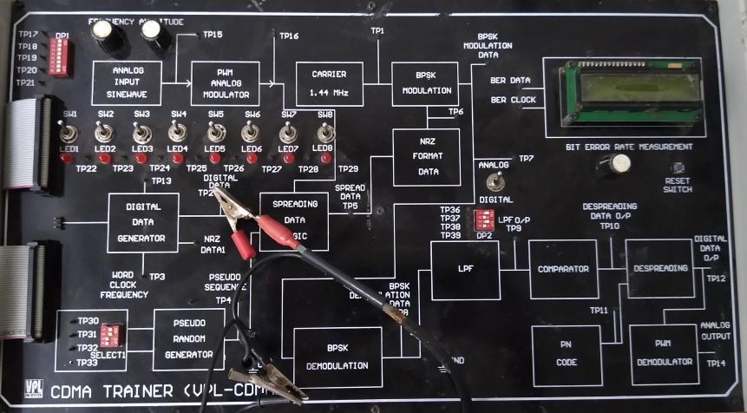

**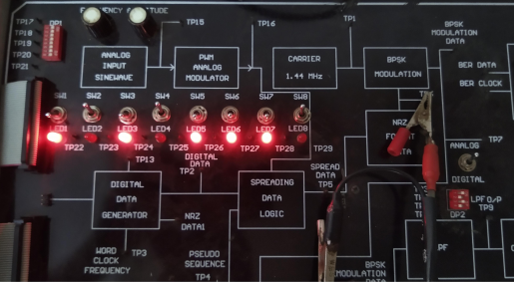**

**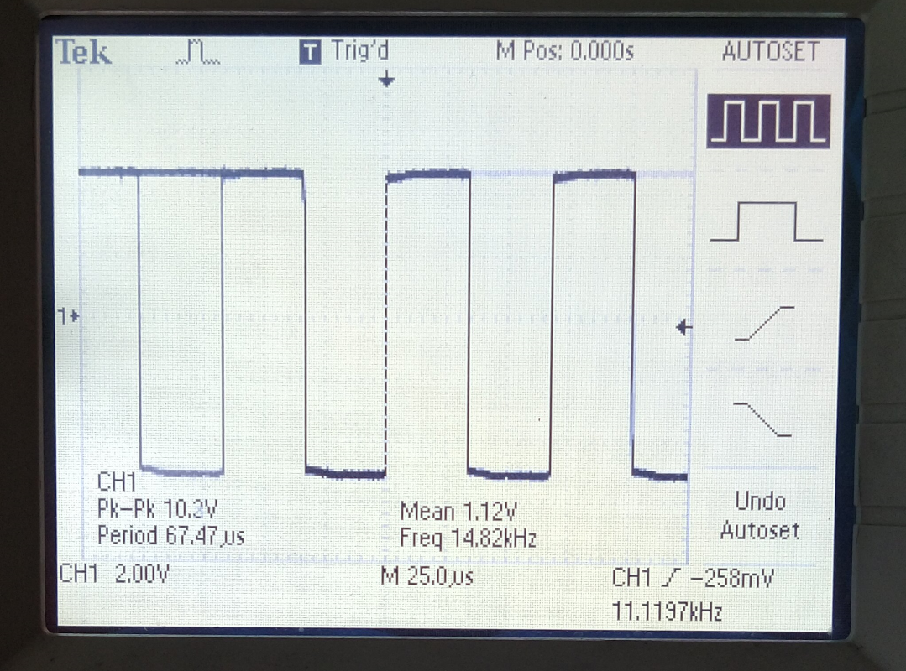**

**PN SEQUENCE:**

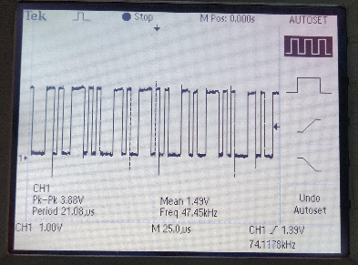

**SPREAD SIGNAL:**

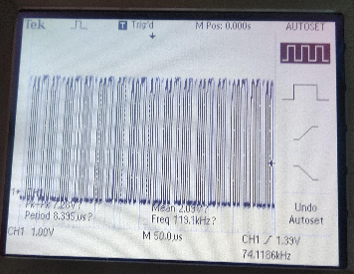

**CARRIER SIGNAL FOR BPSK MODULATION:**

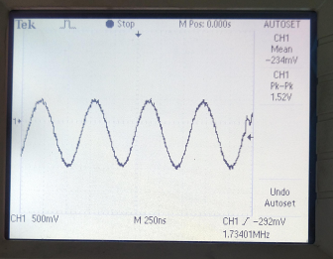

**BPSK MODULATED SIGNAL:**

**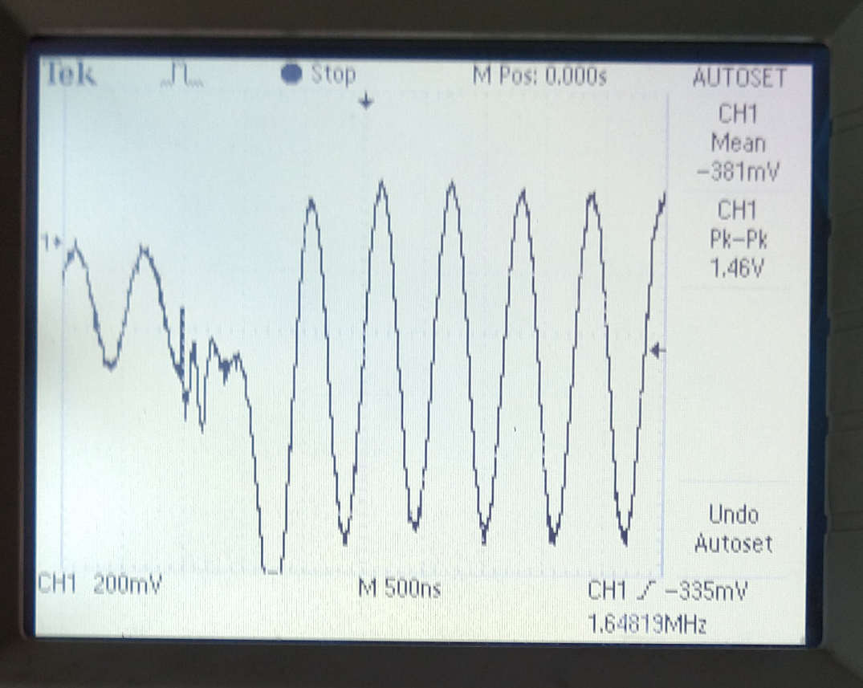**

**Result:**

CDMA receiver using CDMA trainer kit is studied and functions understood

**Experiment - 8**

**Aim:**

Study of CDMA Receiver using CDMA Trainer Kit.

**Apparatus:**

CDMA Trainer Kit, CDMA sim card

**Theory:**

Code-division multiple access (CDMA) is a [channel access method](https://en.wikipedia.org/wiki/Channel_access_method) used by various [radio](https://en.wikipedia.org/wiki/Radio) communication technologies. CDMA is an example of [multiple access](https://en.wikipedia.org/wiki/Channel_access_method), where several transmitters can send information simultaneously over a single communication channel. This allows several users to share a band of frequencies (see [bandwidth](https://en.wikipedia.org/wiki/Bandwidth_(signal_processing))). To permit this without undue interference between the users, CDMA employs [spread spectrum](https://en.wikipedia.org/wiki/Spread_spectrum) technology and a special coding scheme (where each transmitter is assigned a code)

The CDMA receiver gets its input from the transmitter section and recovers the data using a matched filter. The matched filter can distinguish the PN sequence and pass the data to the respective user.

The receiver performs the following steps to extract the Information:

* Demodulation
* Accumulation
* Scaling Serial to parallel conversion
* Multiplying and despreading
* Threshold device

**BPSK DEMODULATED SIGNAL:**

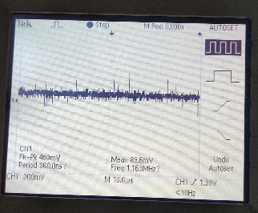

**DECODED SPREAD-SIGNAL:**

**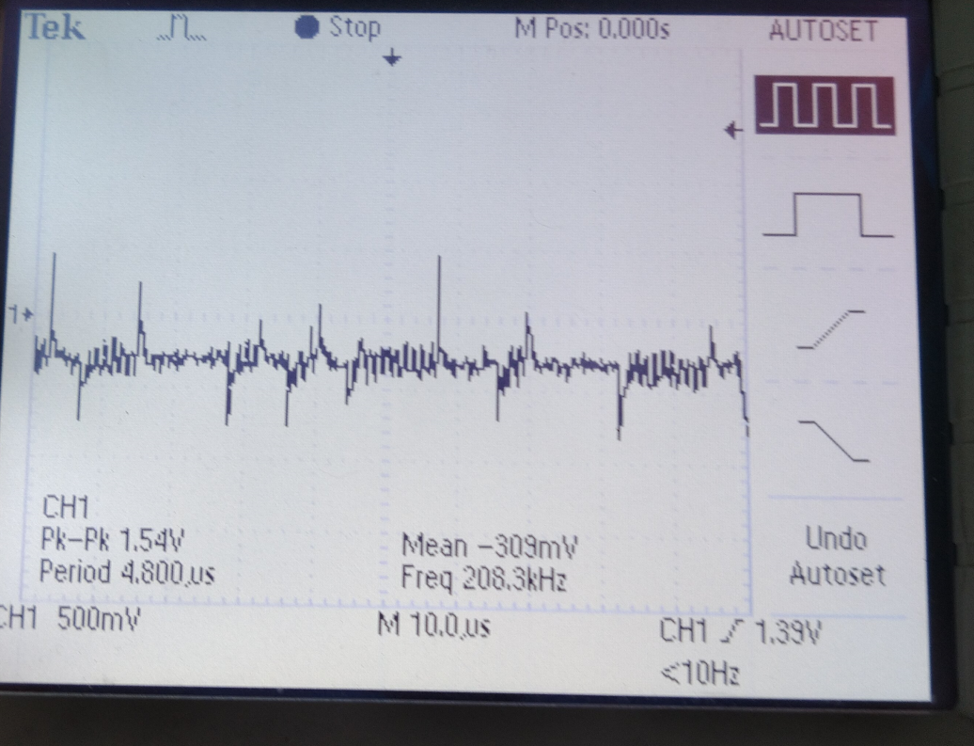**

**PN SEQUENCE AT RECEIVER:**

**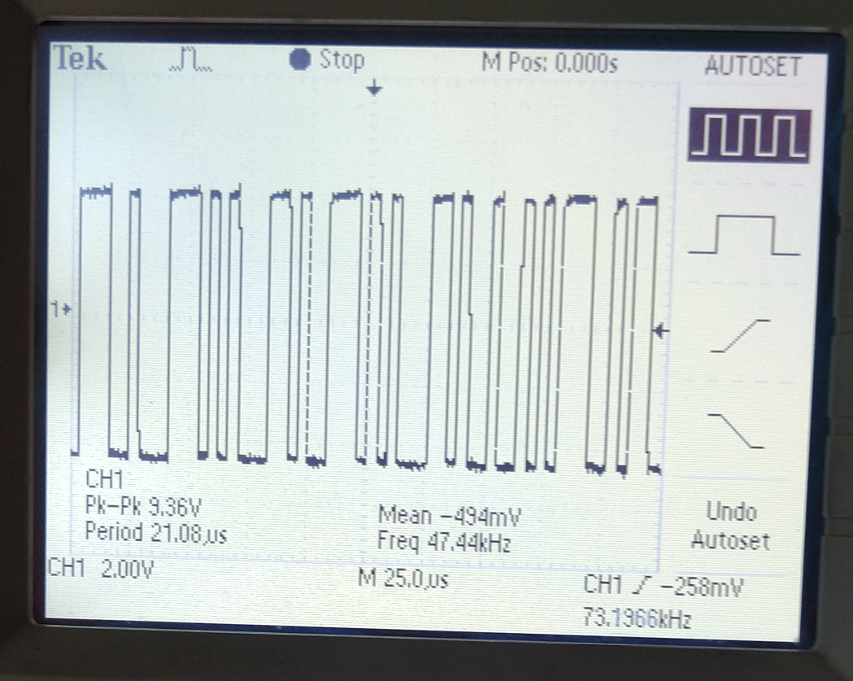**

**RECONSTRUCTED DATA:**

**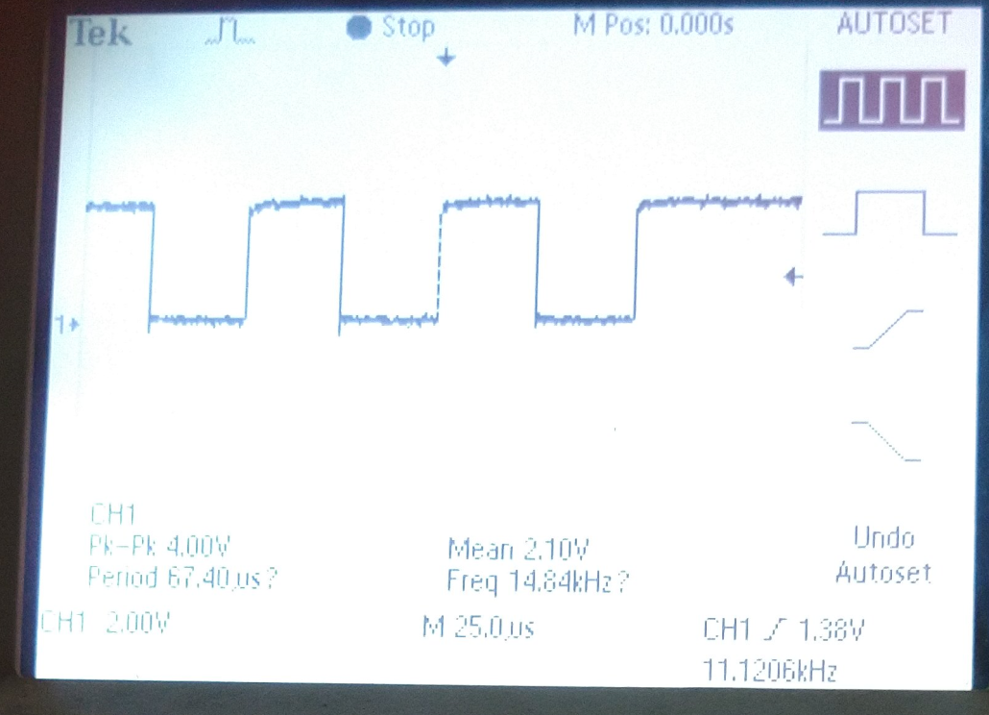**

**BER MEASUREMENT:**

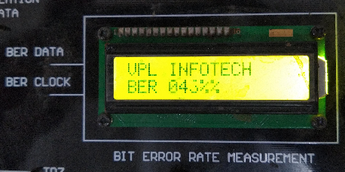

**Result:**

CDMA receiver using CDMA trainer kit is studied and functions understood

**EXPERIMENT 9**

**Aim:**

To study GSM systems using GSM Trainer Kit.

**Apparatus:**

GSM TRAINER KIT, GSM SIM card

**Theory:**

In the GSM system the mobile handset is called Mobile Station (MS). A cell is formed by the coverage area of a Base Transceiver Station (BTS) which serves the MS in its coverage area. Several BTS together are controlled by one Base Station Controller (BSC). The BTS and BSC together form Base Station Subsystem (BSS). The combined traffic of the mobile stations in their respective cells is routed through a switch called Mobile Switching Center (MSC). Connections originating or terminating from external telephone (PSTN) are handled by a dedicated gateway Gateway Mobile Switching Center (GMSC).

|  |
| --- |
| \includegraphics[height=0.40\textheight]{figures/GSM_Arch.eps}  *Fig: The architecture of a GSM system*  In addition to the above entities several databases are used for the purpose of call control and network management. These databases are Home Location Register (HLR), Visitor Location Register (VLR), the Authentication Center (AUC), and Equipment Identity Register (EIR).  Home Location Register (HLR) stores the permanent (such as user profile) as well as temporary (such as current location) information about all the users registered with the network. A VLR stores the data about the users who are being serviced currently. It includes the data stored in HLR for faster access as well as the temporary data like location of the user. The AUC stores the authentication information of the user such as the keys for encryption. The EIR stores stores data about the equipments and can be used to prevent calls from a stolen equipments.  All the mobile equipments in GSM system are assigned unique id called IMSI (International Mobile Equipment Identity) and is allocated by equipment manufacturer and registered by the service provider. This number is stored in the EIR. The users are identified by the IMSI (International Module Subscriber Identity) which is stored in the Subscriber Identity Module (SIM) of the user. A mobile station can be used only if a valid SIM is inserted into an equipment with valid IMSI. The ``real'' telephone number is different from the above ids and is stored in SIM.  **GSM TRAINER:**    **RESULT:**  GSM trainer is studied and functions understood. |
| **EXPERIMENT 10**  **Aim:**  To studythe execution of various AT commands on GSM Trainer Kit  **Apparatus:**  GSM TRAINER KIT, SIM Card  **Theory:**  **AT commands** are used to control MODEMs. AT is the abbreviation for Attention. These commands come from **Hayes commands** that were used by the Hayes smart modems. The Hayes commands started with AT to indicate the attention from the MODEM. The dial up and wireless MODEMs (devices that involve machine to machine communication) need AT commands to interact with a computer. These include the Hayes command set as a subset, along with other extended ***AT commands***.  **Types of AT Commands:**  There are four types of AT commands:    *Fig: Image Showing Classification of AT Commands*  **1)** **Test commands** – used to check whether a command is supported or not by the MODEM.  *SYNTAX*: AT<command name>=?  For example: ATD=?    **2)** **Read command** – used to get mobile phone or MODEM settings for an operation.  *SYNTAX*: AT<command name>?  For example: AT+CBC?    **3)** **Set commands** – used to modify mobile phone or MODEM settings for an operation.  *SYNTAX*: AT<command name>=value1, value2, …, valueN  Some values in set commands can be optional.  For example: AT+CSCA=”+9876543210”, 120    **4)** **Execution commands** – used to carry out an operation.  *SYNTAX*: AT<command name>=parameter1, parameter2, …, parameterN  The read commands are not available to get value of last parameter assigned in execution commands because parameters of execution commands are not stored.  For example: AT+CMSS=1,”+ 9876543210”, 120  **Commands:**  1)Request model identification + CGMM: Used to get the supported frequency band with multiband product the response may be a combination of diff bands  COMMAND > AT+CGMM  SIMCOM – SIM900A  **GSM TRAINER:**    **OUTPUT:**        **RESULT:**  GSM AT commands are studied and understood. |